Estimation Lesson 4 The 3D EKF and UKF

[1. Sebastian Introduction](https://classroom.udacity.com/nanodegrees/nd787/parts/a1505b23-c1aa-4bc6-a94c-d44d062d0209/modules/19b5af05-2ec7-491a-94db-1befc15d07c0/lessons/5c648940-2e88-4d57-b907-57727da7a9b5/concepts/b3274c03-bd21-4a24-a601-11ddbdadcee8)

<https://www.youtube.com/watch?v=SRe2iP8GNxA>

[2. Welcome Back](https://classroom.udacity.com/nanodegrees/nd787/parts/a1505b23-c1aa-4bc6-a94c-d44d062d0209/modules/19b5af05-2ec7-491a-94db-1befc15d07c0/lessons/5c648940-2e88-4d57-b907-57727da7a9b5/concepts/5a7db5f6-a384-420a-8850-3a85eae78369)

<https://www.youtube.com/watch?v=UUYupCvLrnk>

[3. 3D Estimation Overview](https://classroom.udacity.com/nanodegrees/nd787/parts/a1505b23-c1aa-4bc6-a94c-d44d062d0209/modules/19b5af05-2ec7-491a-94db-1befc15d07c0/lessons/5c648940-2e88-4d57-b907-57727da7a9b5/concepts/e7853064-69b2-4894-8a64-1289e22d1fda)

<https://www.youtube.com/watch?v=kdu0tLy7ut0>

[4. EKF Tradeoffs 1 - State](https://classroom.udacity.com/nanodegrees/nd787/parts/a1505b23-c1aa-4bc6-a94c-d44d062d0209/modules/19b5af05-2ec7-491a-94db-1befc15d07c0/lessons/5c648940-2e88-4d57-b907-57727da7a9b5/concepts/45242938-94ad-4f32-9802-eadd87f016fc)

<https://www.youtube.com/watch?v=U1z5AgzmTZM>

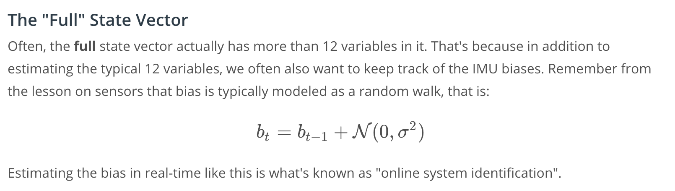

[5. EKF Tradeoffs 2 - Control](https://classroom.udacity.com/nanodegrees/nd787/parts/a1505b23-c1aa-4bc6-a94c-d44d062d0209/modules/19b5af05-2ec7-491a-94db-1befc15d07c0/lessons/5c648940-2e88-4d57-b907-57727da7a9b5/concepts/183f93cc-3317-4449-91b4-9797002ec485)

<https://www.youtube.com/watch?v=CocSTlcO4w0>

## **Additional Reading**

If you're interested in learning more about the tradeoffs associated with using the accelerometer as the control input, this paper goes over a thorough analysis of different approaches: [Fusing Inertial Sensor Data in an Extended Kalman Filter for 3D Camera Tracking](https://eresearch.ozyegin.edu.tr/bitstream/handle/10679/947/Fusing%20inertial%20sensor%20data%20in%20an%20extended%20kalman%20filter%20for%203D%20camera%20tracking.pdf?sequence=2&isAllowed=y)

[6. Attitude Estimation](https://classroom.udacity.com/nanodegrees/nd787/parts/a1505b23-c1aa-4bc6-a94c-d44d062d0209/modules/19b5af05-2ec7-491a-94db-1befc15d07c0/lessons/5c648940-2e88-4d57-b907-57727da7a9b5/concepts/af7043a3-08b2-49cb-8cf2-8101b538d975)

<https://www.youtube.com/watch?time_continue=1&v=kthK1fr4N78>

[7. Complementary Filter Math](https://classroom.udacity.com/nanodegrees/nd787/parts/a1505b23-c1aa-4bc6-a94c-d44d062d0209/modules/19b5af05-2ec7-491a-94db-1befc15d07c0/lessons/5c648940-2e88-4d57-b907-57727da7a9b5/concepts/8ab71eaa-dbb1-4c6b-8003-9f6a200d4f4e)

<https://www.youtube.com/watch?v=SlZoIyvqdPM>

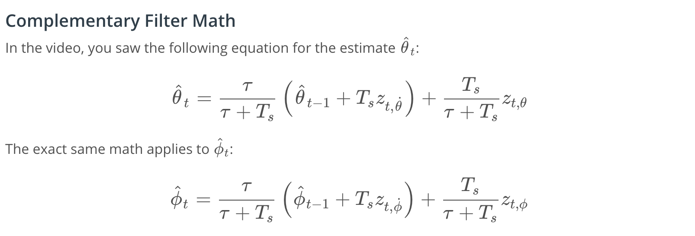

[8. Attitude Estimation Exercise](https://classroom.udacity.com/nanodegrees/nd787/parts/a1505b23-c1aa-4bc6-a94c-d44d062d0209/modules/19b5af05-2ec7-491a-94db-1befc15d07c0/lessons/5c648940-2e88-4d57-b907-57727da7a9b5/concepts/37e0b1bc-6566-44dd-ad68-5330f14cf651)

[Attitude estimation-Student-Revised.ipynb](https://view30846143.udacity-student-workspaces.com/notebooks/Attitude%20estimation-Student-Revised.ipynb)

[9. EKF Implementation 1 - Overview](https://classroom.udacity.com/nanodegrees/nd787/parts/a1505b23-c1aa-4bc6-a94c-d44d062d0209/modules/19b5af05-2ec7-491a-94db-1befc15d07c0/lessons/5c648940-2e88-4d57-b907-57727da7a9b5/concepts/348a2786-3d04-4730-bcca-9a8b4edc9ac2)

<https://www.youtube.com/watch?v=on3hcvv5O7g>

## **Estimation for Quadrotors**

Follow along in [Estimation for Quadrotors](https://www.overleaf.com/read/vymfngphcccj). You will find this document helpful as you complete the final project.

[10. EKF Implementation 2 - Predict](https://classroom.udacity.com/nanodegrees/nd787/parts/a1505b23-c1aa-4bc6-a94c-d44d062d0209/modules/19b5af05-2ec7-491a-94db-1befc15d07c0/lessons/5c648940-2e88-4d57-b907-57727da7a9b5/concepts/f95ee32d-236f-418c-bbaa-85c3c3ad7e40)

<https://www.youtube.com/watch?v=bPPuLzBJ_OE>

## **Estimation for Quadrotors**

Follow along in [Estimation for Quadrotors](https://www.overleaf.com/read/vymfngphcccj). You will find this document helpful as you complete the final project.

[11. EKF Implementation 3 - Update](https://classroom.udacity.com/nanodegrees/nd787/parts/a1505b23-c1aa-4bc6-a94c-d44d062d0209/modules/19b5af05-2ec7-491a-94db-1befc15d07c0/lessons/5c648940-2e88-4d57-b907-57727da7a9b5/concepts/1b2e1b09-69ac-486e-a06d-f34901d8bab1)

<https://www.youtube.com/watch?v=YKbIcSsvWSs>

## **Estimation for Quadrotors**

Follow along in [Estimation for Quadrotors](https://www.overleaf.com/read/vymfngphcccj). You will find this document helpful as you complete the final project.

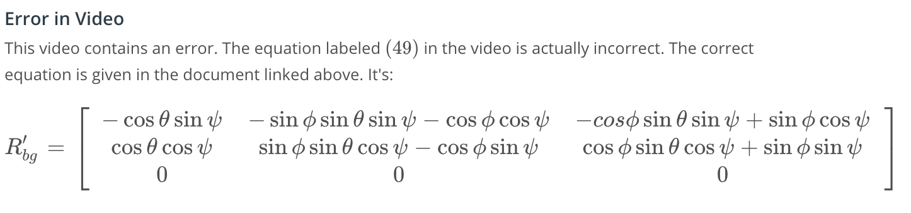

[12. Kalman Recap](https://classroom.udacity.com/nanodegrees/nd787/parts/a1505b23-c1aa-4bc6-a94c-d44d062d0209/modules/19b5af05-2ec7-491a-94db-1befc15d07c0/lessons/5c648940-2e88-4d57-b907-57727da7a9b5/concepts/82ffffed-e277-4fda-b692-c34ad2a2a7b0)

<https://www.youtube.com/watch?v=IBZkNrfBS1A>

[13. Drone in 3D Exercise](https://classroom.udacity.com/nanodegrees/nd787/parts/a1505b23-c1aa-4bc6-a94c-d44d062d0209/modules/19b5af05-2ec7-491a-94db-1befc15d07c0/lessons/5c648940-2e88-4d57-b907-57727da7a9b5/concepts/90699e56-9109-4643-b055-96cf88c0ed77)

[Drone_in_3D-Solution.ipynb](https://view047f2d90.udacity-student-workspaces.com/notebooks/Drone_in_3D-Solution.ipynb)

[14. The Unscented Kalman Filter](https://classroom.udacity.com/nanodegrees/nd787/parts/a1505b23-c1aa-4bc6-a94c-d44d062d0209/modules/19b5af05-2ec7-491a-94db-1befc15d07c0/lessons/5c648940-2e88-4d57-b907-57727da7a9b5/concepts/7818d66a-2276-494f-90ef-6defee929235)

<https://www.youtube.com/watch?time_continue=4&v=uv6rr8QRsMM>

[15. UKF Sigma Points](https://classroom.udacity.com/nanodegrees/nd787/parts/a1505b23-c1aa-4bc6-a94c-d44d062d0209/modules/19b5af05-2ec7-491a-94db-1befc15d07c0/lessons/5c648940-2e88-4d57-b907-57727da7a9b5/concepts/cbeda64e-ef3b-4393-b8cf-be03add4bab1)

<https://www.youtube.com/watch?v=jTTFpHklF6Y>

## **Additional Resources**

* [The Unscented Kalman Filter for Nonlinear Estimation](https://www.seas.harvard.edu/courses/cs281/papers/unscented.pdf) is a short paper (only 6 pages) and does a great job explaining the UKF.
* [A New Extension of the Kalman Filter to Nonlinear Systems](http://citeseerx.ist.psu.edu/viewdoc/download?doi=10.1.1.5.2891&rep=rep1&type=pdf) is a bit longer (12 pages) and includes some helpful example applications.
* [The Scaled Unscented Transformation](https://www.cs.unc.edu/~welch/kalman/media/pdf/ACC02-IEEE1357.PDF) gives a mathematical derivation of the unscented transform.

[16. UKF Predict](https://classroom.udacity.com/nanodegrees/nd787/parts/a1505b23-c1aa-4bc6-a94c-d44d062d0209/modules/19b5af05-2ec7-491a-94db-1befc15d07c0/lessons/5c648940-2e88-4d57-b907-57727da7a9b5/concepts/756e6efa-e801-45b2-995f-1431515b5d23)

<https://www.youtube.com/watch?v=Gp_Suwa6yt0>

[17. UKF Update](https://classroom.udacity.com/nanodegrees/nd787/parts/a1505b23-c1aa-4bc6-a94c-d44d062d0209/modules/19b5af05-2ec7-491a-94db-1befc15d07c0/lessons/5c648940-2e88-4d57-b907-57727da7a9b5/concepts/dbd90d06-58f0-46df-9054-dcf36b504464)

<https://www.youtube.com/watch?time_continue=1&v=I-lLigA1cfc>

[18. UKF Exercise](https://classroom.udacity.com/nanodegrees/nd787/parts/a1505b23-c1aa-4bc6-a94c-d44d062d0209/modules/19b5af05-2ec7-491a-94db-1befc15d07c0/lessons/5c648940-2e88-4d57-b907-57727da7a9b5/concepts/061010aa-e2ed-42d2-a587-0c31defd6ebd)

[UKF-Student.ipynb](https://view0c532c09.udacity-student-workspaces.com/notebooks/UKF-Student.ipynb)

[19. Conclusion](https://classroom.udacity.com/nanodegrees/nd787/parts/a1505b23-c1aa-4bc6-a94c-d44d062d0209/modules/19b5af05-2ec7-491a-94db-1befc15d07c0/lessons/5c648940-2e88-4d57-b907-57727da7a9b5/concepts/258779a9-2383-48f2-ad34-e3ddf254c963)

<https://www.youtube.com/watch?v=SlMwUVc5JzY>

## **Additional Resources**

We **highly** recommend [this Github repository](https://github.com/rlabbe/Kalman-and-Bayesian-Filters-in-Python) as a resource to learn more about Kalman Filters. It contains interactive Jupyter notebooks which cover these algorithms in detail. Chapter 10 covers UKFs and 11 is on EKFs.

#### **Extended Kalman Filters**

Did you know that the Crazyflie uses an EKF for state estimation? The code is open source and you can [check out the repository here](https://github.com/bitcraze/crazyflie-firmware/blob/master/src/modules/src/estimator_kalman.c).

This implementation is based on two papers:

1. [A covariance correction step for Kalman filtering with an attitude](http://muellerlab.berkeley.edu/wp-content/uploads/2016/11/P_2016_CovarianceCorrectionStepForKalmanFilteringWithAnAttitude.pdf)
2. [Fusing ultra-wideband range measurements with accelerometers and rate gyroscopes for quadrocopter state estimation](http://www.mwm.im/ResearchFiles/Papers/FusingUltra-widebandRangeMeasurementsWithAccelerometersAndRateGyroscopesForQuadrocopterStateEstimation.pdf)

#### **Unscented Kalman Filters**

* [The Unscented Kalman Filter for Nonlinear Estimation](https://www.seas.harvard.edu/courses/cs281/papers/unscented.pdf) is a short paper (only 6 pages) and does a great job explaining the UKF.
* [A New Extension of the Kalman Filter to Nonlinear Systems](http://citeseerx.ist.psu.edu/viewdoc/download?doi=10.1.1.5.2891&rep=rep1&type=pdf) is a bit longer (12 pages) and includes some helpful example applications.
* [The Scaled Unscented Transformation](https://www.cs.unc.edu/~welch/kalman/media/pdf/ACC02-IEEE1357.PDF) gives a mathematical derivation of the unscented transform.